Health and medical care
Health is the most important thing in our lives. But people don’t usually appreciate it enough until they (or people close to them) are ill. To prevent illnesses, you have to look after your health. You should eat healthily, exercise regularly, sleep enough and also care about your mental health.
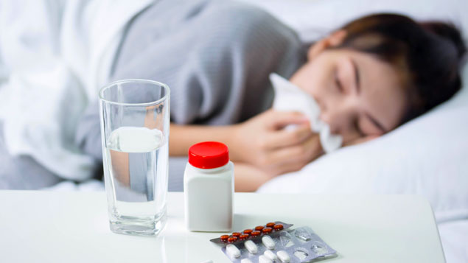
We can divide illnesses into two categories – minor and serious. Minor illnesses are for example flu, cough, sore throat, stomach ache, head ache, fever. Serious illnesses are for example cancer, pneumonia, heart diseases, diabetes or stroke.
How do you recognize for example a cold? You wake up in the morning with an aching head, a scratchy throat and a stuffy nose. In that case, you should go see the doctor. What is the doctor going to do? He can take your temperature, look into your throat, listen to your heart, check your lungs and listen to your breath or check your blood pressure.
How long does it take to recover from a bad cold? For adults, a common cold will usually clear up on its own within about 7 to 10 days. If you have a cough, it may take you a little longer to recover. Adults need about 18 days to completely recover from a cough while kids may require a good three weeks.
To prevent yourself from catching a cold, you should eat food with a lot of vitamins in them. Vitamins are essential micronutrients that an organism needs for the proper functioning of its metabolism. You can find a lot of vitamins in fruits and vegetables. People should eat about five portions of fruit and vegetable every day.
Being fit also helps to prevent you from being ill. People should move every day. But unfortunately, these days people live a sedentary lifestyle. They travel by car to work, to the malls, then they come home and sit in front of a TV. That’s not healthy. Everyone should find an activity that they would enjoy. Some people like running, others like swimming, playing tennis or lifting weights. Some people are going to tell you that some sports are better than others, but as long as you move your body you’re fine.
Sometimes bad things can happen and you can injure yourself. You can break your arm or leg. If that happens, first you have to stop any bleeding. Apply pressure to the wound with a piece of clean cloth. Then immobilize the injured area. Don’t try to realign the bone!
But this shouldn’t keep you from doing sports. If you are careful, you’ll be alright. Let’s mention some benefits of exercising. It increases growth and development, it prevents aging, it strengthens your muscles and the cardiovascular system and it reduces stress. It can also help you to lose weight, maintain your weight or gain weight, depending on what’s your goal.
Lots of people suffer from allergies today. We can be allergic to animals, dust, sun, flower pollen, etc. If we have an allergic reaction, we have a rash, red eyes, we sneeze and it can be hard to breathe. Allergic people must take pills.
In the modern society, more and more people suffer from mental illness (such as depression, anxiety, eating disorders, …). Our mental state can effect our physical condition. We should be practicing mental hygiene to feel better. Some ways to be mentally healthy are talking about your feelings, being active, eating well, asking for help, taking a break, being grateful, doing what you enjoy and going out.
Studies have found many health problems related to stress. Stress seems to worsen or increase the risk of conditions like obesity, heart disease, Alzheimer's disease, diabetes, depression, gastrointestinal problems, and asthma.
All in all, people should do everything they can to be healthy. People are often driven by the desire to raise a lot of money and they overlook their health. But in the end, money is useless if you are seriously ill. Rather invest your time and energy in exercising and thinking more about what you are eating so you won’t have to invest your money to medicaments later in life. Everyone has 24 hours in a day and it’s up to everyone how they are going to spend it. Dedicate just 1 hour of a day to exercising and next time you’ll go grocery shopping buy more fruit and vegetable and you’ll constantly feel better.

Common ilnesses
Health problem | Symptoms | Treatment
Allergy | Red eyes, runny nose, sneezing | Take allergy medications
Cough | Forcing air out of your lungs | Stay in bad, drink lemon tea, take vitamins
Cold | Runny nose, scratchy throat | Take vitamins, eat fruit rich in vitamin C, stay in bed, drink tea
Fever | High body temperature | Stay in bed, stay cool, use cold compresses, keep hydrated
Insomnia | Not being able to sleep at night | Eliminate stimulants, make your sleeping environment comfortable, exercise regularly
Sunburn | Red and painful skin | Take cool shower, moisturize your skin, drink extra water

Medical care in the Czech Republic
The Czech health care system is based on a compulsory insurance model, with fee-for-service care funded by mandatory employment-related insurance plans since 1992. According to the 2016 Euro health consumer index, a comparison of healthcare in Europe, the Czech healthcare is 13th, ranked behind Sweden and two positions ahead of the United Kingdom.
The largest public insurance company in the Czech Republic is the Všeobecná Zdravotní Pojištovna known as VZP (General Healthcare Insurance) which provides full coverage health insurance to all Czech citizens, permanent residents of the Czech Republic and those with long-term working permits.

Medical care in the USA
Health care in the United States is provided by many distinct organizations. Health care facilities are largely owned and operated by private sector businesses. 58% of US community hospitals are non-profit, 21% are government owned, and 21% are for-profit.
Healthcare coverage is provided through a combination of private health insurance and public health coverage (e.g., Medicare, Medicaid). The United States does not have a universal healthcare program, unlike other advanced industrialized countries.
Medical care in the UK
Health care in the United Kingdom is a devolved matter, with England, Northern Ireland, Scotland and Wales each having their own systems of publicly funded healthcare, funded by and accountable to separate governments and parliaments, together with smaller private sector and voluntary provision. As a result of each country having different policies and priorities, a variety of differences now exist between these systems.

Vocabulary

appreciate - ocenit
cough -kašel
essential - důležitý, nezbytný
flu - rýma
immobilize - znehybnit
insurance - pojíštění
recover - zotavit se
sedentary lifestyle - sedavý životní styl
sore throat - bolení v krku
stroke - mrtvice

